Design and analysis of the MOSFET differential

amplifier circuit for the following specifications

common mode differential amplifier:

A common mode differential amplifier amplifies the difference between two input signals while rejecting signals that are common to both.

It consists of two transistors, a current source, and load resistors or active loads. The amplifier operates in two modes: differential mode,

where opposite signals are amplified, and common mode, where identical signals are ideally canceled. A key parameter is the Common Mode Rejection

Ratio (CMRR), which indicates how well the amplifier rejects common-mode signals. These amplifiers are widely used in instrumentation, sensor

signal conditioning, and communication systems to improve noise immunity.

CIRCUIT DESIGN:

A common mode differential amplifier consists of two matched transistors,a current source, and load resistors or active loads. The input signals are

applied to the bases of the transistors, while the emitters share a common connection to the current source. In differential mode, when one input

increases and the other decreases, the circuit amplifies the difference between them.In common mode, when both inputs change together, the output ideally remains unchanged, rejecting noise and interference.

The amplifier's performance is characterized by its differential gain, common-mode gain, and Common Mode Rejection Ratio (CMRR).

High CMRR ensures better noise immunity, making this circuit essential in operational amplifiers, instrumentation systems, and communication.

Given question:Design and analyze the differential amplifier for the following spets. V DD =2.2V ,P <= 2.2W Vicm =1.2v V ocm =1.25 v v_{p} = 0.4v perform:DC, transient analysis, frequency response and Extract the parameter

From calculation we got

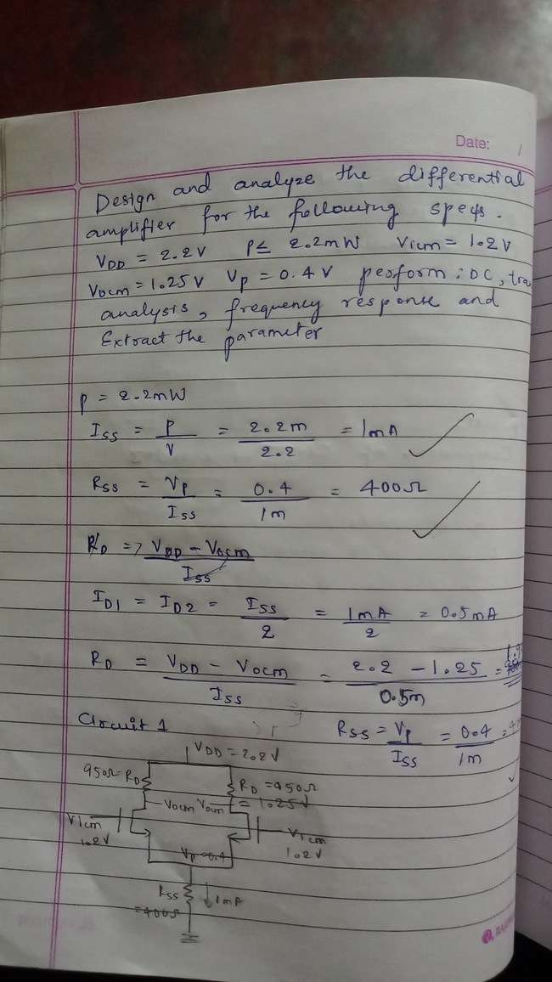

Iss= 1mA

Rd= 1.9kohm

Rss= 400ohm

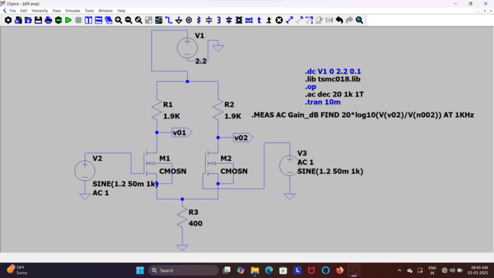

DC operation:

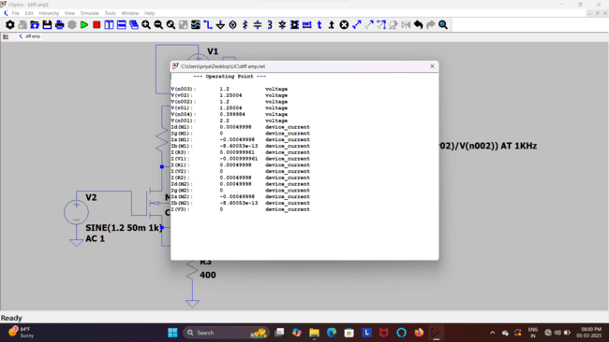

Transient analysis:Transient analysis of a common mode differential amplifier focuses on its time-domain response to changing input signals. It examines how the circuit reacts to step, pulse, or sinusoidal inputs, considering factors like rise time, fall time, and settling time.

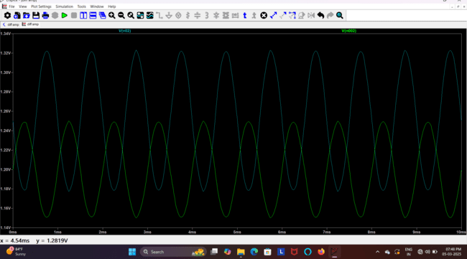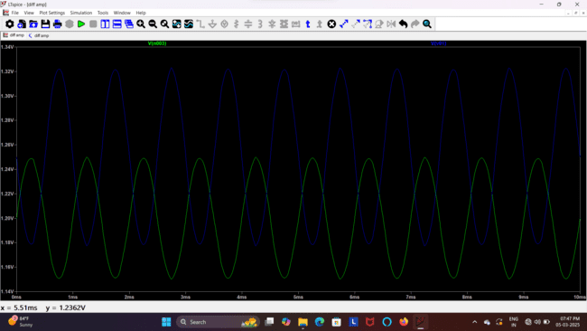

AC Analysis;AC analysis of a common mode differential amplifier evaluates its small-signal gain, impedance, and frequency response. Differential gain is high, while common-mode gain is minimized for better noise rejection. Parasitic capacitances affect bandwidth, and CMRR determines signal integrity. This analysis ensures optimal performance in amplification and filtering applications.

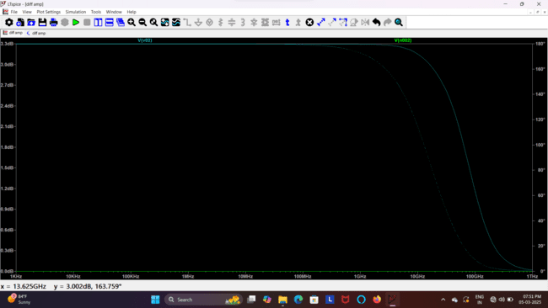

We can observe the bandwidth of the each MOSFET at 3dB in the above pictures of ac analysis of M1 and M2 respectively.

Gain of mosfets in the circuit:

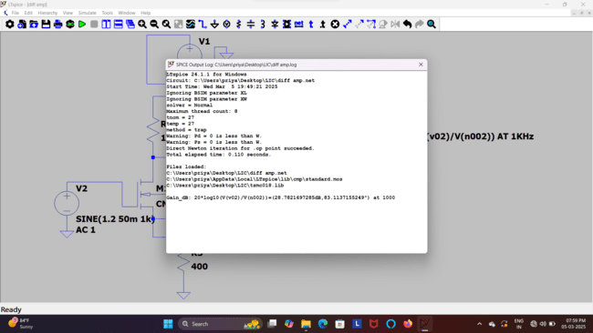

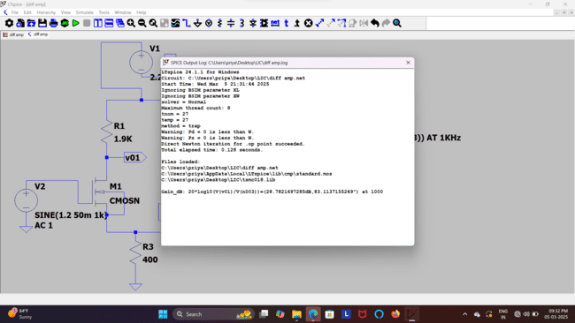

**We can observe gain of each MOSFET is same which Is obtained in dB

MOSFETs in a common mode differential amplifier have the same gain because they are typically matched transistors operating under identical conditions. Their transconductance (), drain resistance, and bias currents are nearly equal, ensuring symmetrical operation.

In differential mode, when one MOSFET increases conduction, the other decreases by the same amount, maintaining balance. This symmetry results in equal but opposite gains for both transistors, ensuring proper differential amplification and minimizing common-mode signal amplification.

Gain in V/V

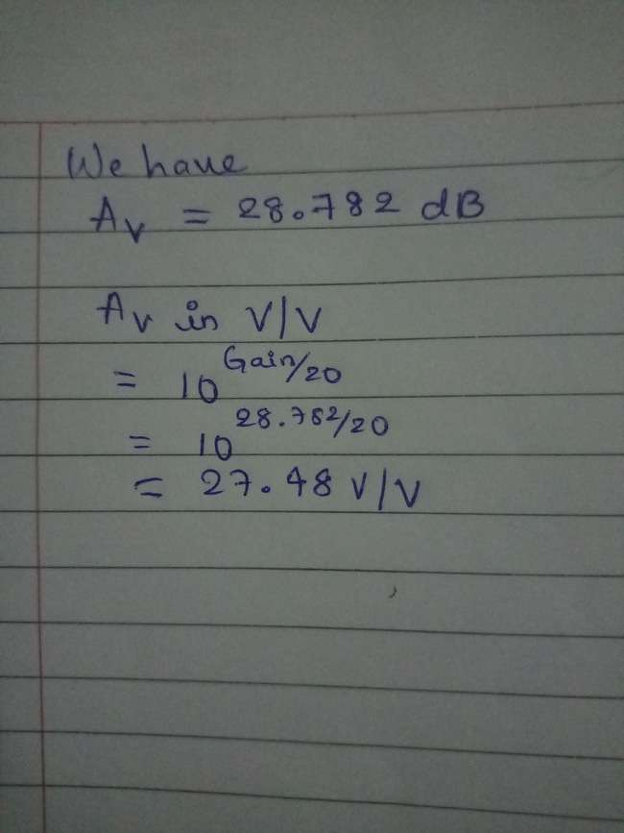

Other parameters from the simulation:

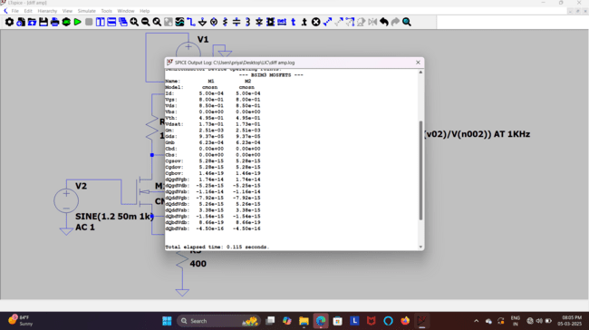

Next for the circuit 2: replace Rss by current source of the value Iss

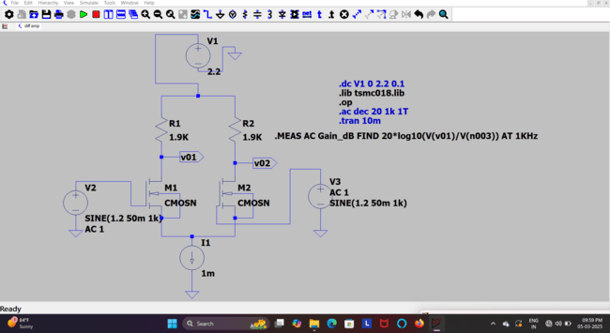

DC operation:

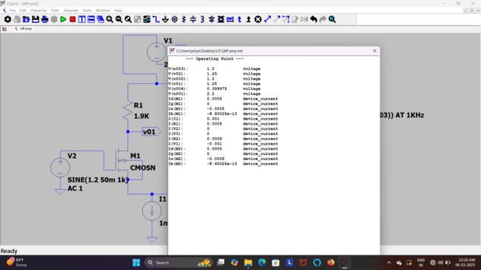

Transient analysis is a method used to study how a circuit's voltages and currents change over time in response to varying inputs or initial conditions. It helps engineers analyze the behavior of circuits before they reach a steady state. This type of analysis is essential for understanding signal propagation, switching behavior, and dynamic performance in electronic circuits. It is commonly applied to RC, RL, and RLC circuits, as well as oscillators, filters, and digital logic circuits. By solving time-dependent differential equations, transient analysis provides insight into how circuits respond to sudden changes, such as power-on conditions or signal transitions.

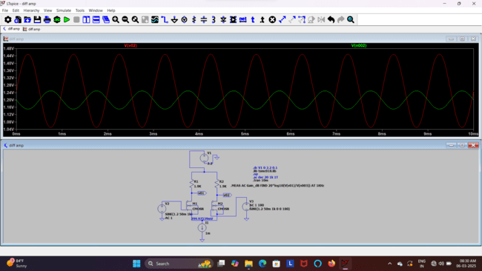

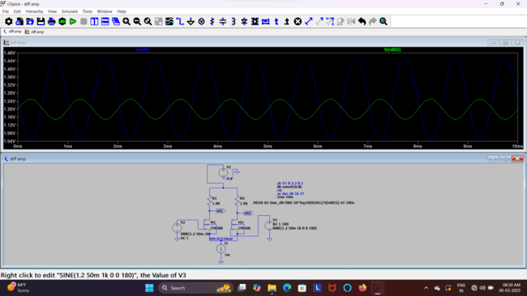

Vout peak to peak and Vin peak to peak aste same from both the MOSFETs

Manual gain calculation:

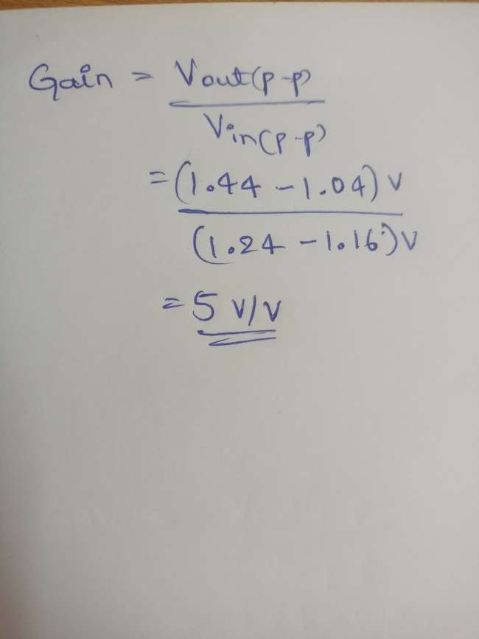

Gain in dB from the simulation of the circuit:

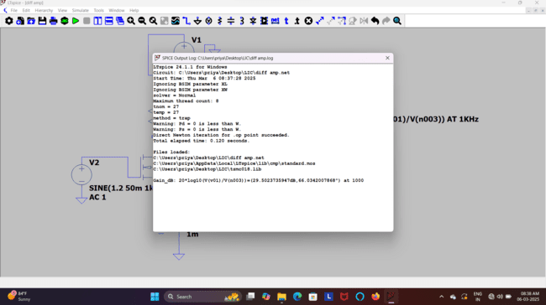

AC analysis:

AC analysis of a differential amplifier helps evaluate its frequency response, gain, and phase shift across different frequencies. It determines how effectively the amplifier amplifies the difference between two input signals while rejecting common-mode signals. This analysis assumes a small AC signal is applied, and the circuit is linearized around its DC operating point. The results typically include the differential gain, bandwidth, and phase response, which are crucial for designing high-performance amplifiers. By plotting a Bode plot, engineers can observe the gain in dB and phase shift over a frequency range, helping optimize circuit performance for specific applications.

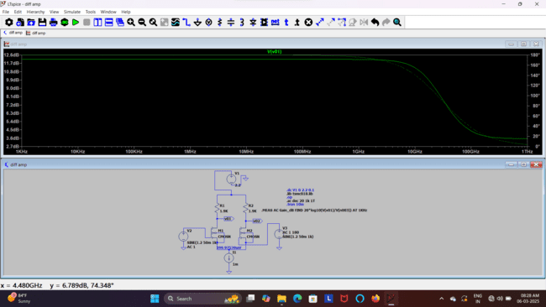

To calculate the bandwidth from the graph:

1. Identify the maximum gain (mid-band gain)

From the Bode plot, the maximum gain is around 12.6 dB.

2. Find the -3dB point

The bandwidth is the frequency at which the gain drops by 3 dB from the maximum.

Since the max gain is 12.6 dB, we look for the frequency where the gain reaches 9.6 dB.

3. Locate the -3dB frequency on the graph

From the graph, the gain starts rolling off around the GHz range.

The cursor shows 4.48 GHz with a gain of 6.789 dB, which is already lower than -3dB from the peak.

Observing the graph, the -3dB point appears to be around 3 GHz to 3.5 GHz.

Estimated Bandwidth

Bandwidth ≈ 3.2 GHz (approximate value based on visual interpretation).

Circuit 3: we replace the current source by the MOSFET having the input signal Vb.

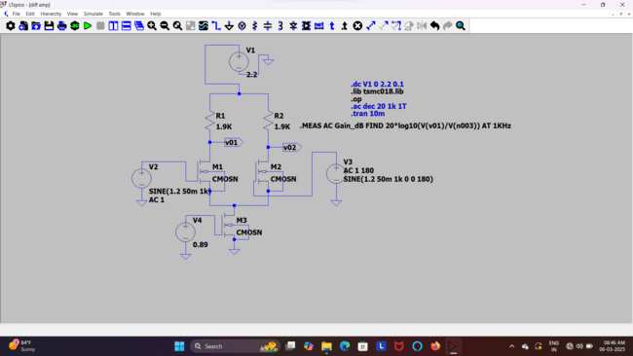

To get Id of M3 ,we arranged the value of w and L of MOSFET:

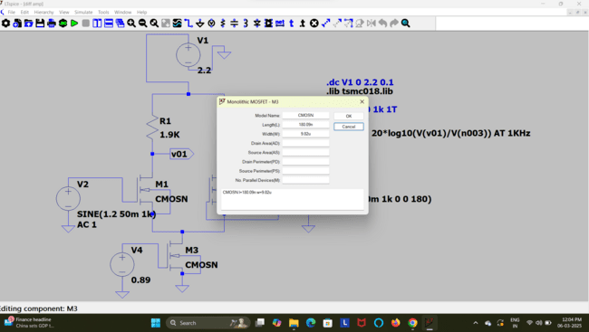

Manual calculation of Vgs of M3 using data sheet:

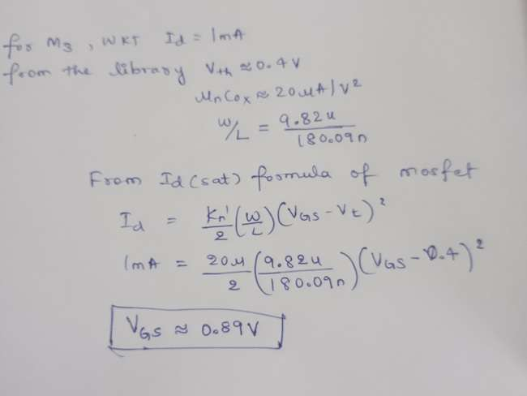

Transient analysis:

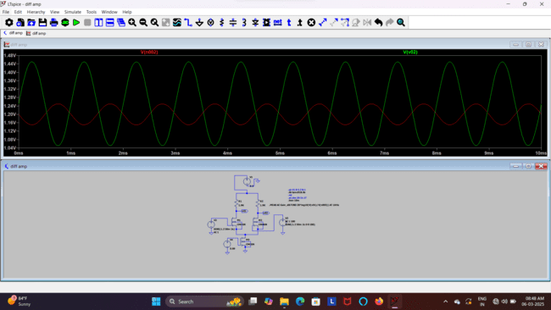

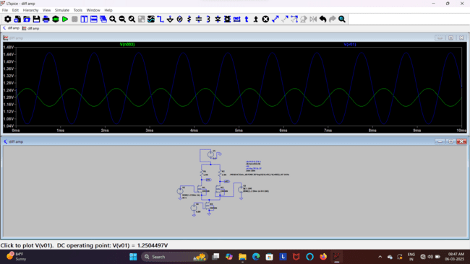



Gain of circuit 2 and Circuit 3 remains same

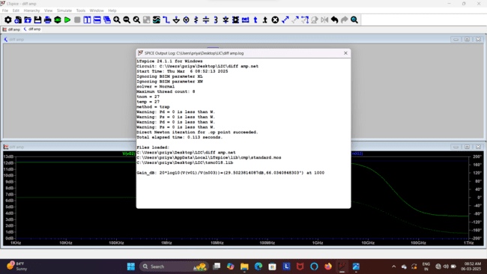

AC analysis:

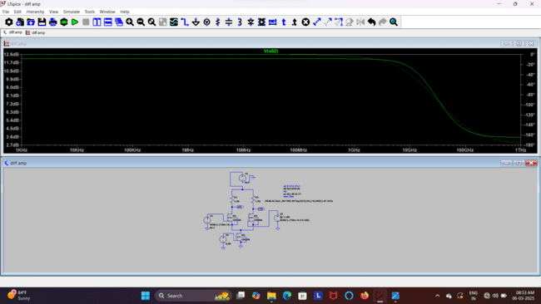

To calculate the bandwidth from the given AC analysis graph,

Step 1: Identify the Midband Gain

From the graph, the maximum gain is approximately 12.6 dB.

Step 2: Find the -3dB Point

Bandwidth is defined as the frequency range where the gain is within -3dB of the peak gain.

The -3dB point is:

12.6 dB - 3 dB = 9.6 dB

From the cursor at 4.48 GHz, the gain is 6.789 dB, meaning the -3dB point occurs at a lower frequency.

Observing the plot, the -3dB cutoff appears around 3-4 GHz.

Step 3: Estimate the Bandwidth

Lower cutoff frequency (fL): Since it's a differential amplifier, low-frequency cutoff is usually very low (near DC).

Upper cutoff frequency (fH): From the graph, it's approximately 4 GHz.

Final Answer:

The bandwidth of the differential amplifier is approximately 4 GHz.

Inference of Common-Mode Analysis in a Differential Amplifier:

Common-mode analysis of a differential amplifier helps determine how well the circuit rejects noise or unwanted signals that appear equally on both inputs. Here are the key inferences:

1. Common-Mode Gain ()

Ideally, a differential amplifier should have a very low common-mode gain.

In practical circuits, due to device mismatches, a small common-mode gain exists.

2. Common-Mode Rejection Ratio (CMRR)

CMRR = , where is the differential gain.

A high CMRR indicates better rejection of noise and power supply variations.

Typically, MOSFET-based differential amplifiers (like in your circuit) have a high CMRR due to current source biasing.

3. Impact of Mismatch

Resistor mismatches and MOSFET threshold variations can increase common-mode gain, reducing CMRR.

The addition of active loads or tail current sources improves CMRR by ensuring better symmetry.

4. Frequency Response in Common Mode

The common-mode bandwidth is usually different from the differential mode.

At high frequencies, common-mode rejection may degrade due to parasitic capacitances.

5. Practical Applications

A high CMRR is essential in sensor interfaces, communication circuits, and operational amplifiers to reject power supply noise and external interference.

Final Conclusion:

A well-designed differential amplifier should exhibit low common-mode gain and high CMRR, ensuring better signal integrity by rejecting external noise and interference effectively.